NOTICE
NOTICE
of eNVIRONMENTAL determination
ISSUANCE OF A DETERMINATION OF NON-SIGNIFICANCE - MITIGATED (DNS-M)
Posted to Notify Interested Persons of an Environmental Action
project name: VIA 405 APARTMENTS
PROJECT NUMBER: LUA17-000237
Location: 25 S Grady Way
Description: The applicant is requesting a Preliminary Planned Urban Development (PUD) land use decision and threshold determination under the State Environmental Policy Act (SEPA) for the construction of 270 multi-family dwelling units and associated improvements. The 2.6 acre site is located within the Commercial Office (CO) zoning classification and Commercial Mixed Use (CMU) land use designation. The site's existing 42,700 square foot movie theater building will be removed.
Proposed structural improvements include a new eight (8) story 289,300 square foot building with parking located on portions of the first two (2) floors and dwelling units and amenity areas located on the upper six (6) floors. The net density of the completed project would result in 141 dwelling units per acre. Ground level uses along the north facade include two (2) commercial spaces, residential amenity areas, lobby, and the building’s leasing office. Exterior improvements include a plaza and active recreation space abutting the northeast portion of the building, pedestrian pathway link to the Metro Park and Ride on S. Grady Way, landscaping, and stormwater improvements. Access to the site includes driveway easements connecting to S. Grady Way and S. Renton Village Pl.
Critical Areas identified on City maps include Flood Hazard, Seismic Hazard, Regulated Slopes, and a Non-Fish Perennial (Np) stream. A stream buffer determination as it relates to non-regulated sites separated from critical areas by pre-existing substantial improvements will also be a component of the PUD application. The applicant has identified 63 significant trees on-site and proposes to retain 32 trees abutting the stream and two (2) trees outside of the stream vicinity. The following reports have been submitted with the land use application: Preliminary Technical Information Report, Arborist Report, Critical Areas Assessment, and Geotechnical Report.
the city of renton environmental review committee (erc) has determined that the proposed action MAY have a significant adverse impact on the environment.
Appeals of the environmental determination must be filed in writing on or before 5:00 p.m. on September 1, 2017, together with the required fee with: Hearing Examiner, City of Renton, 1055 South Grady Way, Renton, WA 98057. Appeals to the Examiner are governed by City of RMC 4-8-110 and information regarding the appeal process may be obtained from the Renton City Clerk’s Office, (425) 430-6510.
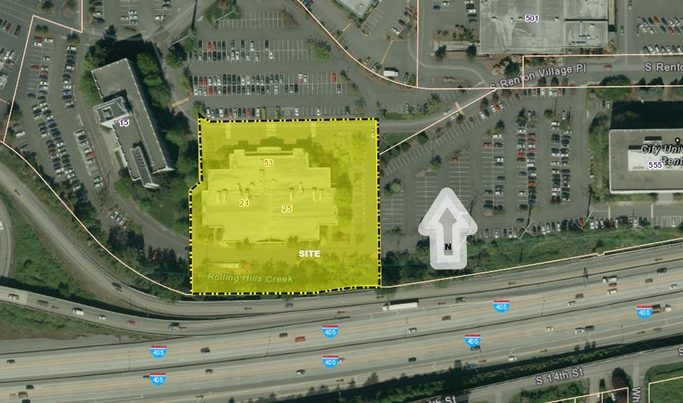
A Public Hearing will be held by the Renton Hearing Examiner at his regular meeting in the Council Chambers on the 7th floor of City Hall, 1055 South Grady Way, Renton, Washington, on September 26, 2017 at 11:00 am to consider the Preliminary planned urban development. If the Environmental Determination is appealed, the appeal will be heard as part of this public hearing.

